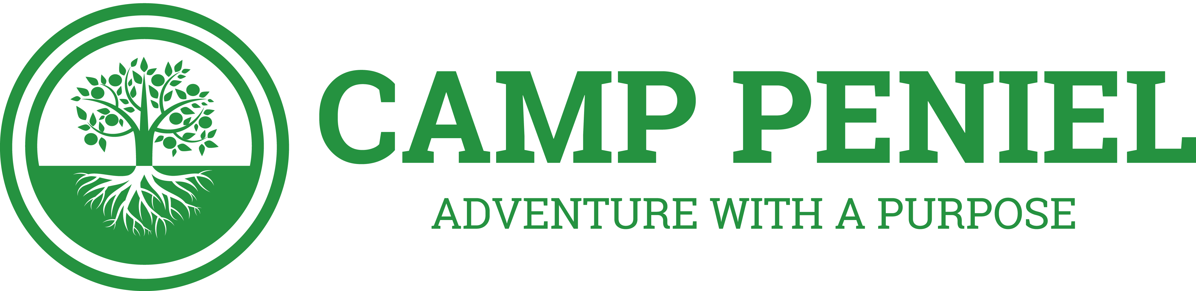
CAMP PENIEL GOLF TOURNAMENT SPONSORSHIP

Greetings from Camp Peniel!

Please mark Saturday, October 22, 2022 down in your calendar! Camp Peniel will be hosting our Annual Charity Golf Tournament and we would like you to be a part of it! The tournament will take place at Delaware Springs Golf Course in Burnet, TX. Camp Peniel has been used by the Lord to bring thousands of campers “face-to-face” with Him for 75 years and we are excited for how He will continue to use us in the future!

The monies raised from this event will go towards growing camp’s Campership Fund which provides financial assistance and has an Eternal impact the lives of young people and families throughout the year!

I invite you to impact the life of a camper & consider one of the following sponsorship options below:
  - Board sponsor: $75 (8 x 24 sign displayed by clubhouse)
  - Hole sponsor: $250 (16 x 24 sign displayed on the course)
  - Specialty Hole: $300 (Exclusive hole sponsorship, 16 x 24 sign at tee box)
  - Hole & Board: $300 (both 8 x 24 & 16 x 24 signs displayed)

You may register via www.camppeniel.org/golf-tournament or complete the sponsorship portion of the attached form & scan/email it to me or send it via postal mail to the contact information listed below. All checks can be made payable to Camp Peniel. If you have any questions please feel to contact me at brian@camppeniel.org.

Thank you so much for your consideration of being involved in Peniel’s Annual Charity Golf Tournament and impacting young people and families for Eternity!

Please send form & sponsorship to:
Camp Peniel
Attn. Brian Anderson
397 Peniel Path
Marble Falls, TX 78654

